Exercise 9: Demo about Form Control

Objectives and Outcomes

React provides a way to create form controls and handle form input using its built-in components and state management. This exercise helps you learn how to create a form control using React

Exercises

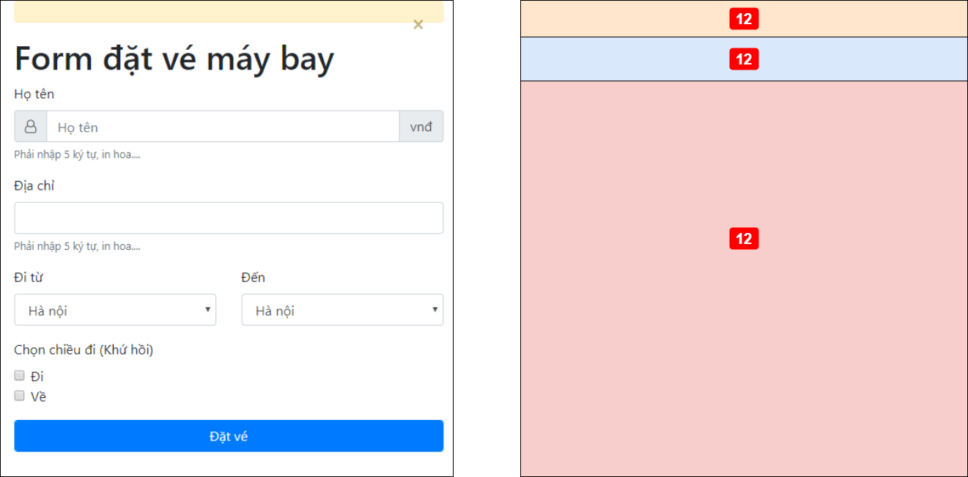

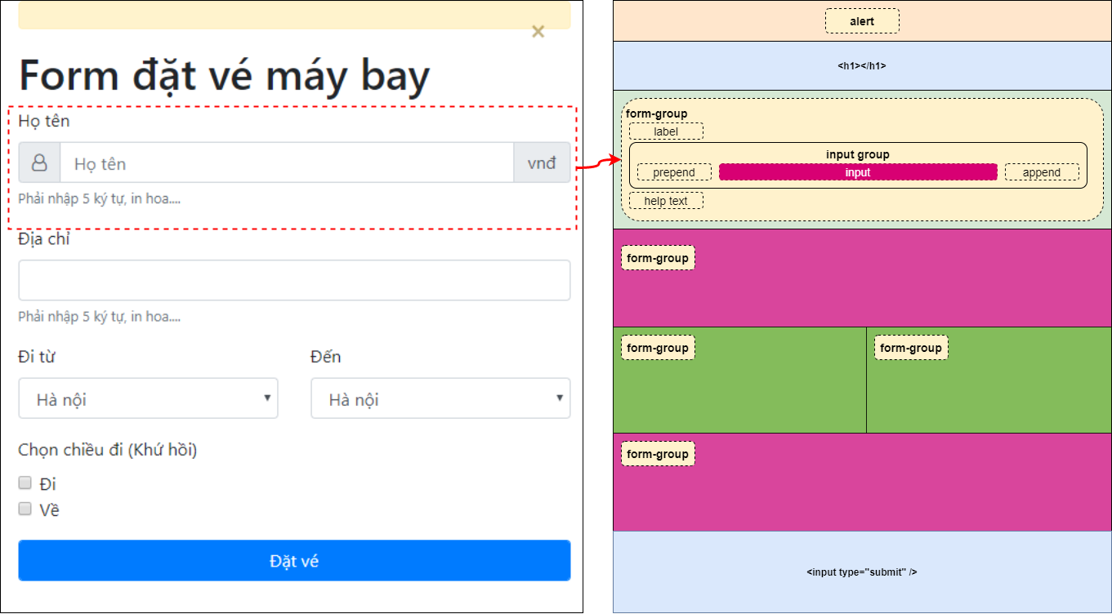

Conclusion

In conclusion, React provides a powerful and flexible way to create form controls and handle form input in your applications. By leveraging React's component-based architecture and state management, you can easily create interactive and controlled form controls.